WALLACE SCHOOL
STRING DEPARTMENT
HANDBOOK

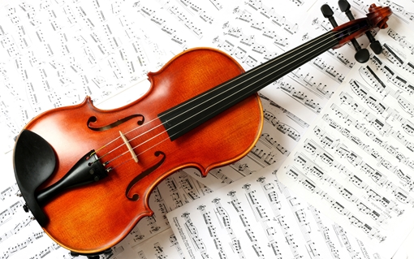

Maria Monblatt
Music Teacher

Dear Music Students, Parents and Guardians,

I am so looking forward to working with you to make our string program the best it can be! This handbook will give you an idea of what great things you can expect from our String Department this year!

If you have received this handbook, your son/daughter has expressed an interest in joining the string program!

In this handbook, you will find the Goals and Rules of the String Department, Dress Code for Performances, Concert Dates & Times, String Guidelines, and lastly, a Consent Form, which all parents and/ guardians must read carefully and sign. After signing, please return this entire handbook to me as soon as possible!

If you have any further questions or concerns, please do not hesitate to contact me at maria.monblatt@hoboken.k12.nj.us .
I wish you all an exciting, productive, successful, and, of course, fun year!

Sincerely,

Maria Monblatt
Music Teacher

String Department Goals

- Provide a safe environment in which students can study and perform music.

- To help develop each student’s creativity and character.

- To help students relate music to other arts and to the world around them.

- To provide students with the fundamental skills and knowledge needed to develop good performance!

String Department Rules

- Be respectful- Being respectful to the people around you means that you should treat others as you would like to be treated!

- Be supportive- Support your classmates- Music takes hard work and practice, and no one can do it alone!

- Be prepared- Be sure to practice at least 30 minutes every week! Always remember to bring your instrument, folder and music to class! You are responsible for your instrument and your music, and both require great care!

- Do your best- Learning an instrument takes 100%! Students must practice, work hard, and always put forth their best effort!

- Have Fun!!!!!

Dress Code for Performances

  - Boys: Black Pants and a White Shirt

  - Girls: Black Pants or a Black Skirt (below the knee) and a White Shirt

  - Boys and Girls: Black Shoes

String Department
Tentative Concert Date & Time

Thursday, December 15th, 2016 at 7 pm

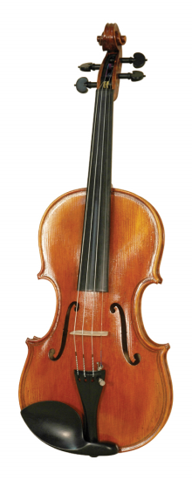

STRING GUIDELINES
(each student is responsible for his/her instrument)

DO clean your instrument by gently wiping it with a soft cloth (after playing is a good time to clean it).

DO make sure your instrument case is completely closed before moving or carrying it!

DO tighten your bow hairs before playing (twist to the right) and loosen your bow hairs before putting your instrument away (twist to the left).

DO leave your instrument in a safe and secure place after you take it home.

DON’T leave your instrument anywhere you wouldn’t be comfortable!

DON’T leave your instrument in a car!

DON’T leave your instrument in a place that is too hot or too cold! This means not next to a heater, air conditioner, or even a window!

DON’T clean your instrument with water!

DON’T leave your instrument out when you are not using it! If you are not playing your instrument, it should be in its case, closed, and put in a safe place!
String Department Consent Form

I have received a copy of the String Department Handbook. I have read and understand the department goals, rules, and grading policy. I will encourage my son/daughter to fulfill all obligations to the instrumental music program.

will have string class
every from .

Parent/ Guardian Signature

Contact Phone Number/ E-mail

Please return this packet to Ms. Monblatt
